Virginia Sports and Spine
4041 University Drive #100, Fairfax, VA 22030
571-344-3744

Name: _____________________________________ Date of Birth: _________________Gender: Male Female
Address: __________________________________________________________________________________
Phone: _____________________________________ Email: ________________________________________
Emergency Contact Name: _____________________ Contact Number: _______________________________
Primary Care Physician: ______________________ Phone Number: ________________________________
Marital Status: Single Married Divorced How did you hear about us? _______________________

Insurance Information

Insurance Name: _____________________________ ID #:_______________________Group #:___________

Assignment of Benefits Authorization

I authorize I have coverage with above insurance company. I hereby assign all my or my dependent’s insurance benefits to Virginia Sports & Spine to charge for the services provided. I understand that I am financially responsible if my insurance company does not pay for the services provided to me. By signing this document, I authorize Virginia Sports & Spine to have access to my insurance benefits, submit claims, and other related services. I have read and understand the above statement.

Printed Name: ______________________________ Signature: ______________________Date: ____________

Notice of Privacy Practices
It is the law that all medical records and other health information used or disclosed by us in any form (electronically, on paper, or orally) are kept confidential and will not be released unless requested by the patient/dependent. The Health Insurance Portability & Accountability Act of 1996 (HIPAA) is a federal program protecting patient’s identity. HIPPA gives the patient the rights to have access to their health information. Breach of this privacy by the provider is penalty by law. Your medical records may be used for the purposes of treatments, payments, and health care operations at our office. I understand that, under the Health Insurance Portability & Accountability Act of 1996 (HIPAA), I have certain rights to privacy regarding my protected health information. I understand this information can and will be used for treatment plans, payments, and other health and office related operations at Virginia Sports and Spine.
Consent to Treat
I have been informed of the nature of my condition(s) and the nature of Chiropractic services to provide treatment. I have also been informed of the possible risks of the treatment(s) and understand that there is no guarantee for any specific cure or result. I have read and understand the above statement. I hereby authorize Virginia Sports and Spine to proceed with Chiropractic treatments.
Name: ___________________________________ Signature: ________________________ Date: ___________
Chief Complaints

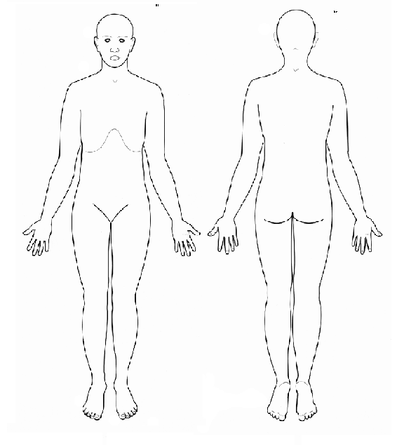
Reason for today’s visit: _________________________________________
How it started? ________________________________________________
When it started? _________________ Does it radiate? _________________
Aggravates it? __________________ Alleviate it? ____________________
Quality of pain (sharp, tingling ____) You pain scale: 0 1 2 3 4 5 6 7 8 9 10
Is it constant? Yes or No Does it wake you up at night? Yes or No
Are you currently being treated for this condition? Yes or No
If yes by whom and what treatment? _______________________________

Please mark pain areas.

Socials History

Are you pregnant? No or Yes Due Date: ______________
Exercise: None Moderate Daily What type of exercise? _________________________________________
Diet? (Vegan/Vegetarian, Paleo, high processed/Fast food, etc.)_______________________________________
Do you smoke? Yes No How much? ___________Do you drink? Yes No How much? _________________
Work activity? ______________________________________________________________________________

Past Medical History
Physical Exam results: _______________________________________________________Date: ___________
X-ray/MRI/Labs results: _____________________________________________________ Date: ___________
Injuries: __________________________________________________________________ Date: ___________
Surgeries: _________________________________________________________________Date: ___________
Hospitalizations: ___________________________________________________________ Date: ___________
Medications: ______________________________________________________________ Date: ___________
Immunizations: ____________________________________________________________ Date: ___________
Allergies: ________________________________________________________________ Date: ___________

Family Medical History
Father’s medical conditions: _________________________________________________________________
Mother’s medical conditions: ________________________________________________________________
Children’s medical conditions: _______________________________________________________________

